**CASH REGISTER PRIME INSTALLATION STEPS**

1. **Unzip and copy cash register prime application in C:\AMW\Wrk\AlliedFeatures\CashRegPrime**



1. **Voucher number series must be defined in Control parameters as below**

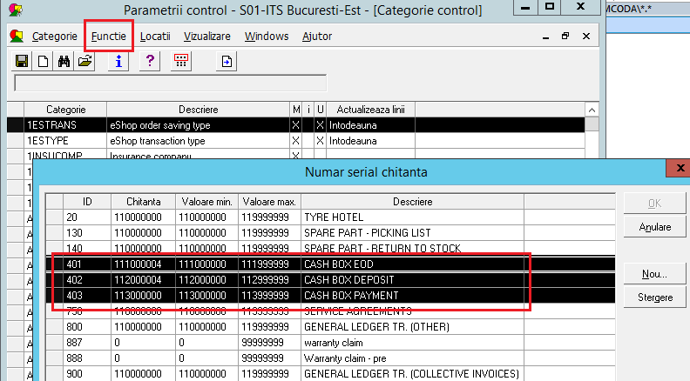

1. **Install below card for parameters:**

* CASHDENOM
* CASHFORM
* CASHTYPE
* CASHREG
* CASHBOXID



1. **Run old application am0ycarg.exe and create cash type lines as below**

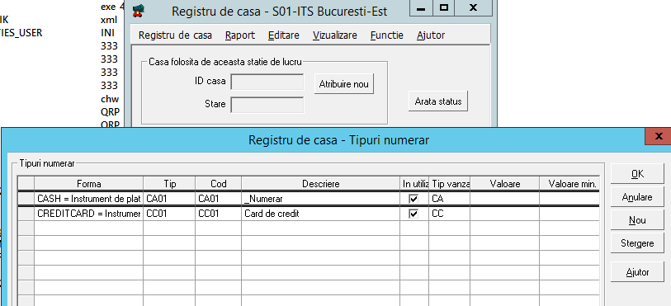

1. **In win.ini for every user must be added the line: ZCULTUREINFO=ro-RO**
2. **In SQL Management Console run scripts below**

CREATE FULLTEXT CATALOG [FTCAT_AMDMS]WITH ACCENT_SENSITIVITY = OFF  
AS DEFAULT  
AUTHORIZATION [dbo]  
GO  
  
alter table TEMPINV add PAYDATE datetime, PAYSUM numeric(18,6)  
GO

grant select,insert, update,delete on TEMPINV to public  
GO  
  
drop view [dbo].[ASVIEW_CAREG_UNPAID_INVOICE]   
go  
  
CREATE view [dbo].[ASVIEW_CAREG_UNPAID_INVOICE] with SCHEMABINDING as select   
a.INVID, a.UNITID, cast(a.RECNO as varchar) as RECNO,a.APPAREA,cast(a.ORDNO as varchar) as ORDNO,a.INVSUM,a.INVSUM0,a.BILLD,  
cast(a.CUSTNO as varchar) as CUSTNO,isnull(a.LNAME,'') as LNAME,isnull(a.FNAME,'') as FNAME,a.DEPT, isnull(a.PAYSUM,0) as PAYSUM, a.DUED  
from dbo.TEMPINV a where PAYDATE is null and a.CREDIT =0 and a.CRERECNO is null  
and a.RECACCNO is not null  
GO

SET ANSI_PADDING, ANSI_WARNINGS, CONCAT_NULL_YIELDS_NULL, ARITHABORT,  
QUOTED_IDENTIFIER, ANSI_NULLS ON;  
GO

CREATE UNIQUE CLUSTERED INDEX [IDX_ASVIEW_CAREG_UNPAID_INVOICE] ON [dbo].[ASVIEW_CAREG_UNPAID_INVOICE]   
(  
[INVID] ASC  
)WITH (PAD_INDEX = OFF, STATISTICS_NORECOMPUTE = OFF, SORT_IN_TEMPDB = OFF, IGNORE_DUP_KEY = OFF,   
DROP_EXISTING = OFF, ONLINE = OFF, ALLOW_ROW_LOCKS = ON, ALLOW_PAGE_LOCKS = ON, FILLFACTOR = 90) ON [PRIMARY]  
GO  
  
CREATE FULLTEXT INDEX ON ASVIEW_CAREG_UNPAID_INVOICE(RECNO,ORDNO,CUSTNO,LNAME,FNAME) key index IDX_ASVIEW_CAREG_UNPAID_INVOICE on FTCAT_AMDMS  
  
grant select on ASVIEW_CAREG_UNPAID_INVOICE to public  
select * from ASVIEW_CAREG_UNPAID_INVOICE

1. **Repeat the below step for all sites**

drop view [dbo].[ASVIEW_CAREG_PAID_INVOICES01]   
go

CREATE view [dbo].[ASVIEW_CAREG_PAID_INVOICES01] with SCHEMABINDING  
as   
select   
a._OID,CAST(a.RECEIPTNO as varchar) as RECEIPTNO, a.UNIT as UNITID, isnull(cast(a.INVOICENO as varchar),a.EXT_INVOICENO) as RECNO,a.MODULE,  
isnull(cast(a.ORDERNO as varchar),a.EXT_ORDERNO) as ORDNO,a.AMOUNTTOPAY,a.TOTPAID-ISNULL(a.CASHRETURNED,0) as TOTPAID,a.UPDATED_DATE as PAYDATE,  
a.EXT_BILLD as BILLD,cast(a.CUSTNO as varchar) as CUSTNO,b.LNAME,b.FNAME, a.CASHBOXID, a.DEPARTMENT,a.LICNO,  
isnull(a.CREDITNEWNO,0) as CREDITNEWNO,ISNULL(a.CREDITNOTE,0) as CREDITNOTE, ISNULL(a.CREDITOFNO,0) as CREDITOFNO  
from dbo.CASHTRANSHS01 a , dbo.CUST b where a.CUSTNO = b.CUSTNO  
go  
  
SET ANSI_PADDING, ANSI_WARNINGS, CONCAT_NULL_YIELDS_NULL, ARITHABORT,  
QUOTED_IDENTIFIER, ANSI_NULLS ON;  
GO

CREATE UNIQUE CLUSTERED INDEX [IDX_ASVIEW_CAREG_PAID_INVOICES01] ON [dbo].[ASVIEW_CAREG_PAID_INVOICES01]   
(  
[_OID] ASC  
)WITH (PAD_INDEX = OFF, STATISTICS_NORECOMPUTE = OFF, SORT_IN_TEMPDB = OFF, IGNORE_DUP_KEY = OFF,   
DROP_EXISTING = OFF, ONLINE = OFF, ALLOW_ROW_LOCKS = ON, ALLOW_PAGE_LOCKS = ON, FILLFACTOR = 90) ON [PRIMARY]  
GO  
  
CREATE FULLTEXT INDEX ON ASVIEW_CAREG_PAID_INVOICES01(RECEIPTNO,RECNO,ORDNO,CUSTNO,LNAME,FNAME) key index IDX_ASVIEW_CAREG_PAID_INVOICES01 on FTCAT_AMDMS  
  
grant select on ASVIEW_CAREG_PAID_INVOICES01 to public  
  
--Create the Control data INVCAT_ADD manually if not exists, run this script for all sites

insert into CORWS01(CODAID,C1,C3,C4,C5) select 'INVCAT_ADD',SUBSTRING(codaid,1,1)+C1,CODAID,C1,C1 from CORWS01 where CODAID in ('klaskutyy','alaskutyy','vlaskutyy') and c5 like '%L%'

1. **In SQL Management Console run scripts below**



1. **Install below SSRS reports**



1. **Set the correct path in control data and bat file for the reports**
2. **Import below install cards**



1. **Set the correct mapping in ZMP55CONV for VAT codes**
2. **Check AMWMESSAGE\TMPINV_WR and AMWCONNECT\TMPINVODBC**

